Tonhe Timer Instruction
1 Parameter specifies
Working voltage :110～250VDC(110～230VAC)
The time for keeping valve open :0 H : 0M :0S --99 H 59 M 59 S
The time for keeping valve closed : 0 H : 0M :0S --99 H 59 M 59 S
2 Timer specification

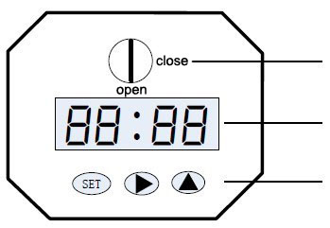
Set button, Location selection button, Increasing button
4 digital time display
Position indicator

3 Operation instruction

Actuator parameter setting have two menu structures on below:
Function code ( fist menu),
The setting parameters of function code ( secondary menu)
Normal operation
First menu

Secondary menu

Picture 0 Secondary menu operation menu

Function code | Content | Value | Unit | Remarks
t on | valve keeping open time  open | 00:00:00 – 99:59:59 | H:M:S
toFF | valve keeping closed time | 00:00:00 – 99:59:59 | H:M:S
PonS | Power -on Action | On/off
Prot | Stall current setting | 0-599 | MA | When the current is bigger than the setting value 1.6S, the motor will stop working , and the display will show Err.
Parameter function control table

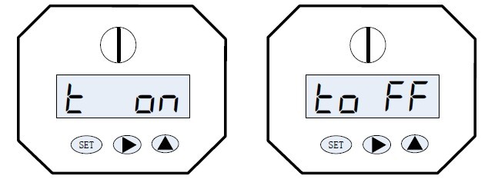

Picture 1 picture 2
1 Press 2 seconds and enter to fist menu, the screen display picture 1 text（t on） , indicating enter to set the valve keeping open state .
Pressagain, the screen display picture 2 text （t o FF）,indicating enter to set the valve keeping closed state .

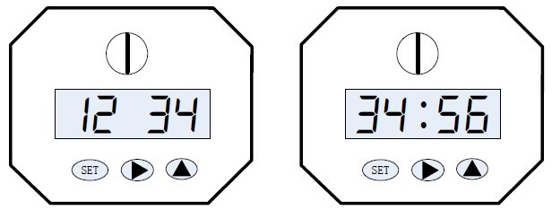
Picture 3 picture 4
2 Press then the after entering the stetting state , showing the valve keeping time for setting ( Set the valve keeping open time on the valve keeping open state . Set the valve keeping closed time on the valve keeping closed state.) . Select flashing bit by pressing, and change the numerical by pressing.

When " : " is flashing , indicate setting "HS ( hours) :MS(minutes)", and change the flashing fit by pressing.
When the " : " is bright , indicate setting " MS(minutes) :SS(seconds) " .
The data will be deposited in the valve controller after completing the setting .
Press when finish setting , will return fist menu , press again , enter to next fist menu to set parameters .

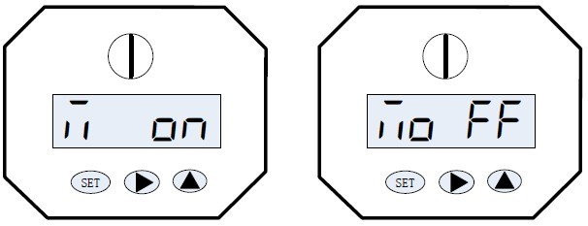

Picture 5 picture 6
3 Press the&, the screen display picture 5 , indicating open the valve manually.
Press the&, the screen display picture 6, indicating closed the valve manually .
Exit manual mode to press the& or &. And go the power -on action .

Picture 7 picture 8
4 On the normal working state, the displayed time is valve keeping time.(e.g. Valve keeping open time is 10 S, will count down 10S)
The " : " is flashing , indicating the "HS ( hours) : MS(minutes)"' .
The " : " is bright, indicating the " MS(minutes) : SS(seconds) " .

4 Stalling protection function

When the actuator is detected stalling, it will run in reverse direction .when reach to the open or closed position , and do the close or open action again , meanwhile displaying flashed 0000-0001 on screen ( indicating the current retrying times ) . If it fail at third retrying , the valve will stop running and display ERRL on the screen .

